Via email from blog visitor: Note how sharp and clear most of the photos are and these are over 100 years old. There aren't many old photos as good, remember they didn't have film or digital photo cards those days. Most probable is that these were glass plate images and taken through a pin hole type camera and the opening was timed just right to get a dark enough exposure. Developing was another tedious task as they had to be careful not to break the glass.

American Cities a Century Ago
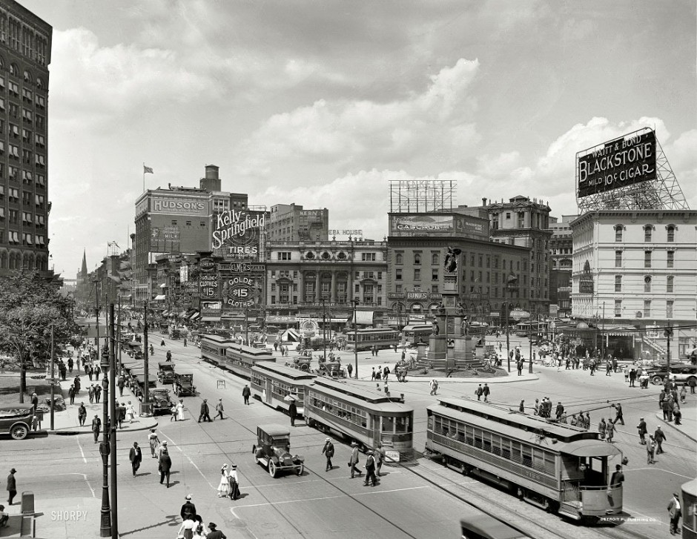
Woodward Avenue, Detroit, Michigan, in 1917.

2.
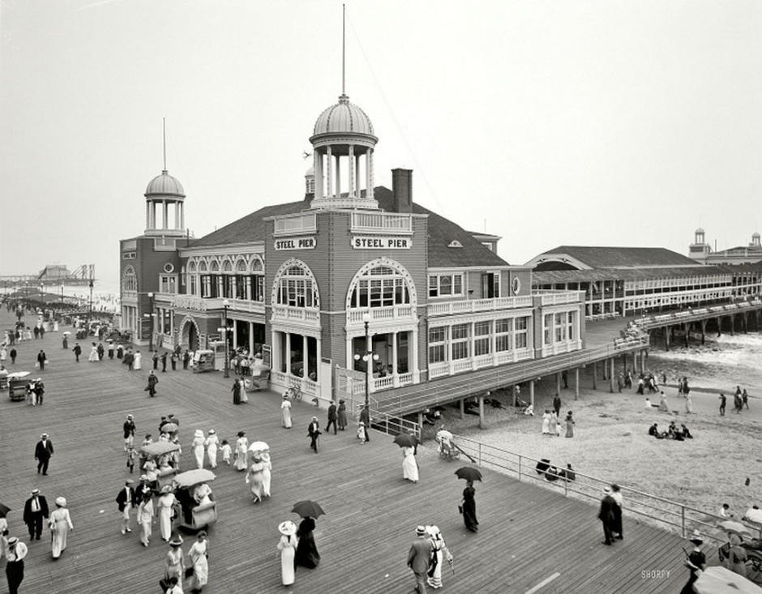
Atlantic City, 1910.
Wonder why they're carrying umbrellas - no sun! No rain!

3.
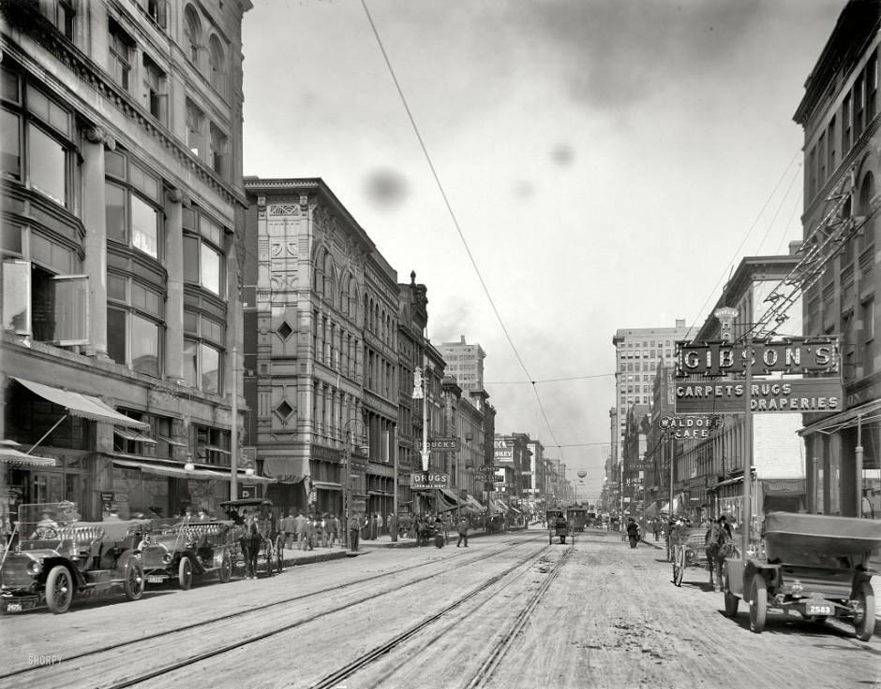
The main street of Memphis, north of Avenue Gayoso, 1910.

4.
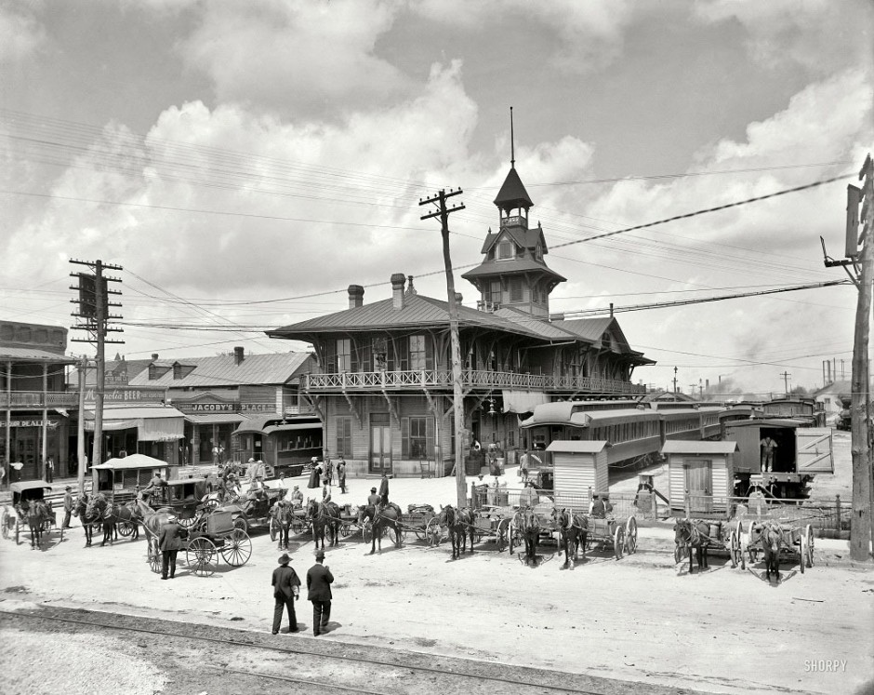
Station â€œLouisville-Nashville, Florida, in 1910.

5.
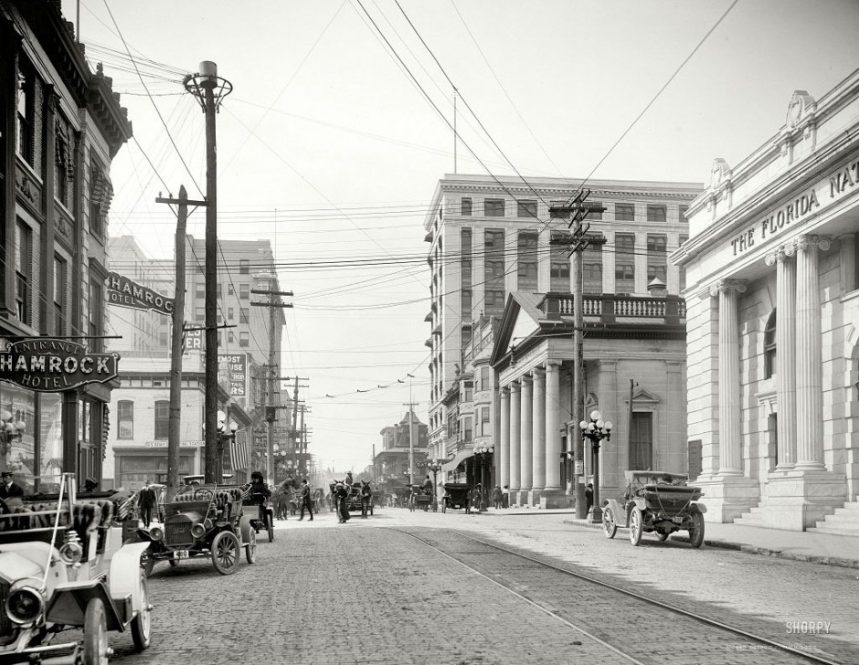
Forsyth Street, Jacksonville, Florida, in 1910.
Love those cars.

6.
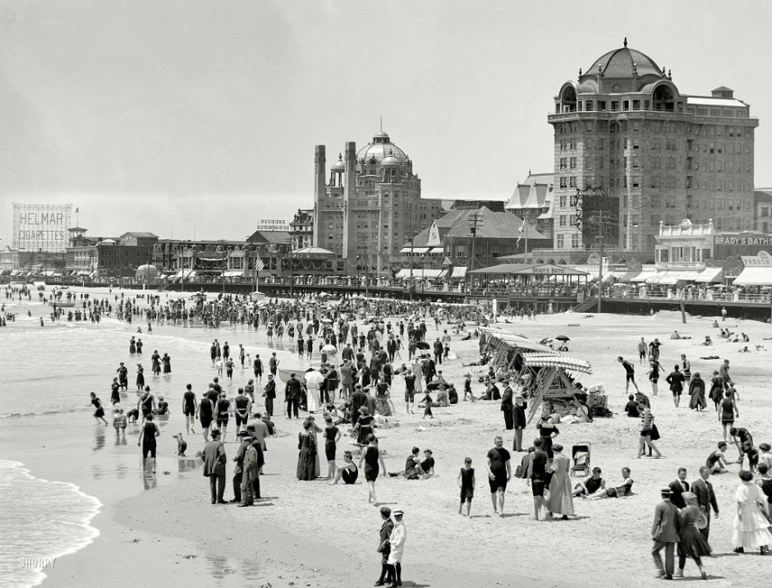
The beach in Atlantic City, 1915.

7.
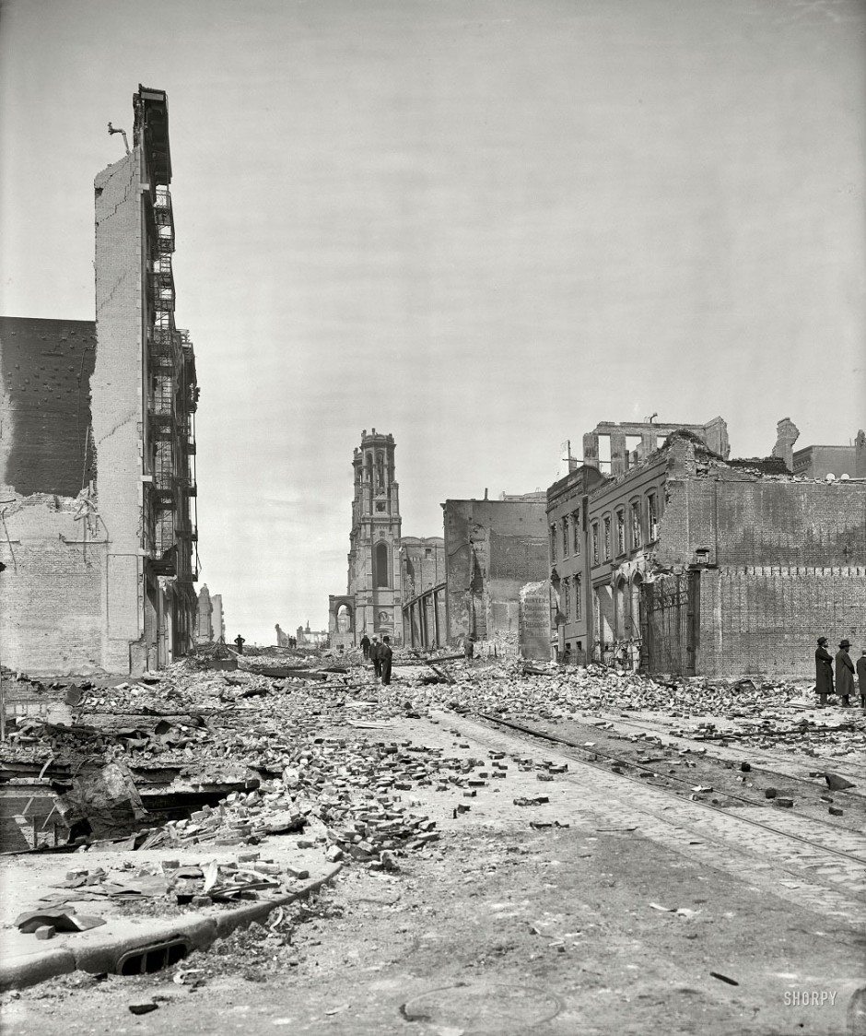
Grant Avenue after an earthquake in San Francisco in 1906.
I didn't realize there was so much destruction in that earthquake.
8.
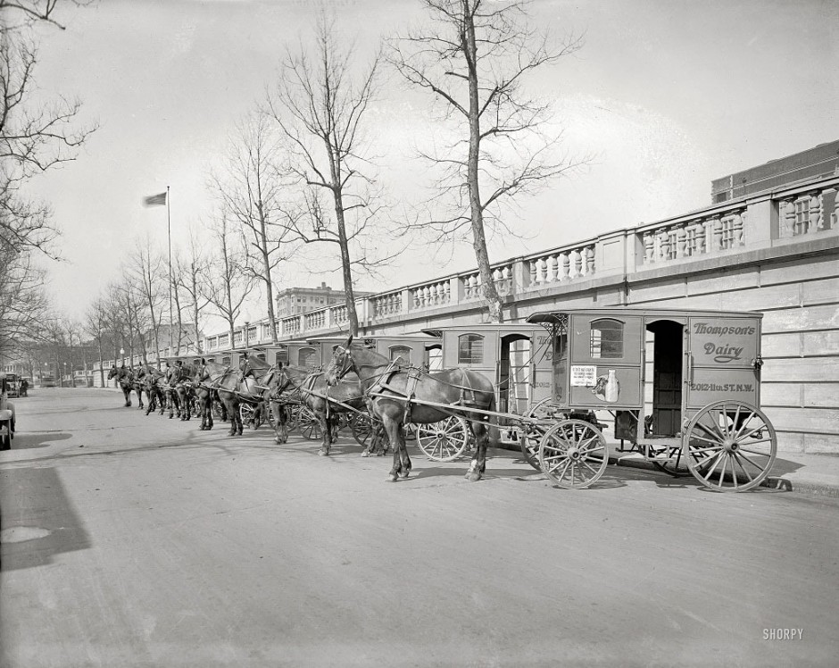
Carts for transporting dairy Thompson, Washington, 1927.
How in the world did the dairy get those horses so evenly lined up.

9.
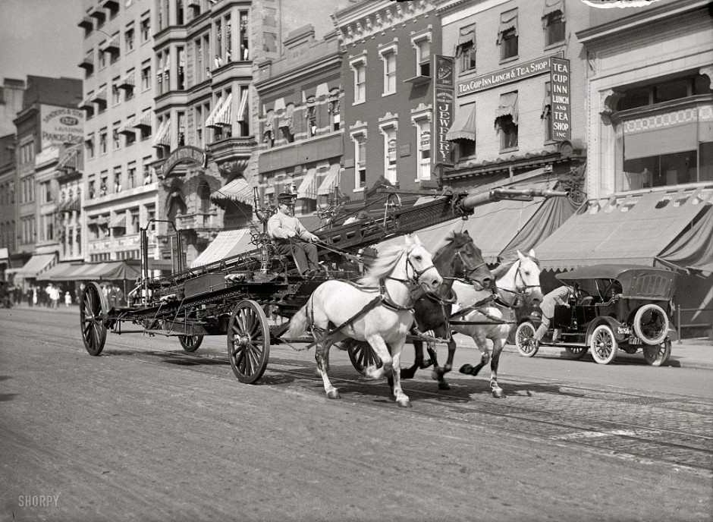
Washington, DC, 1914.
Not so thoughty having those horses run on a railroad tracks.
(thoughty? must have been a popular word back in the day)

10.
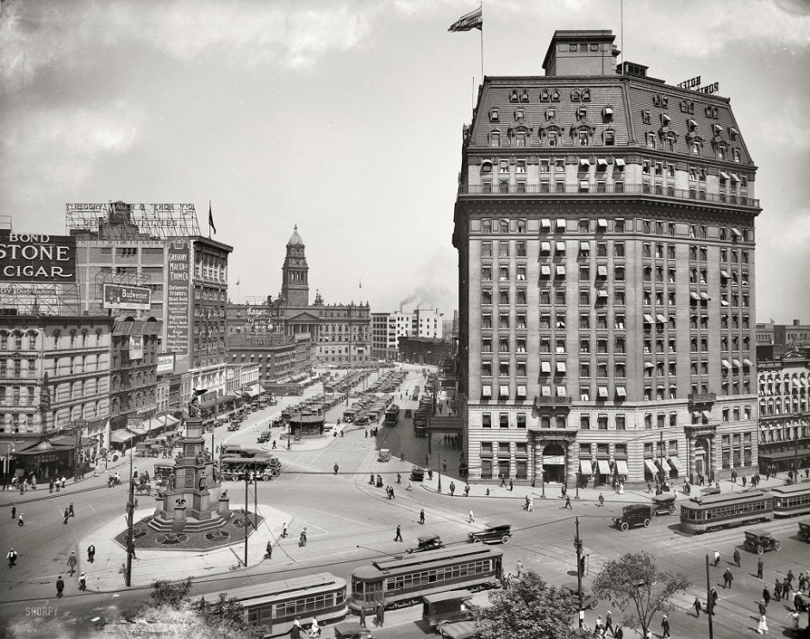
Cadillac Square, Detroit, Michigan, 1916.

11.
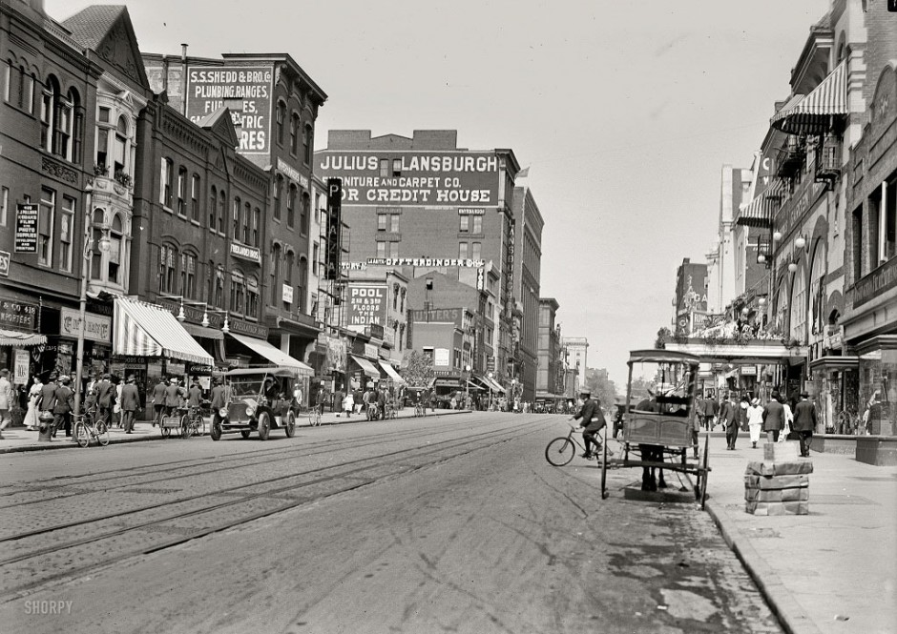
Ninth Street, Washington DC, 1915.

12.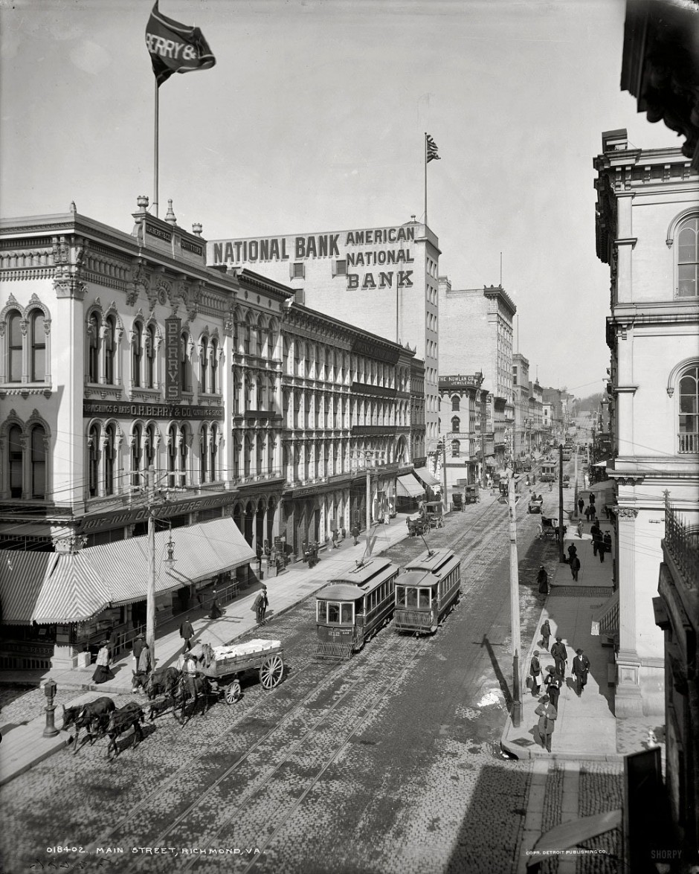
I wouldn't want to walk across this street in a long dress.
13.
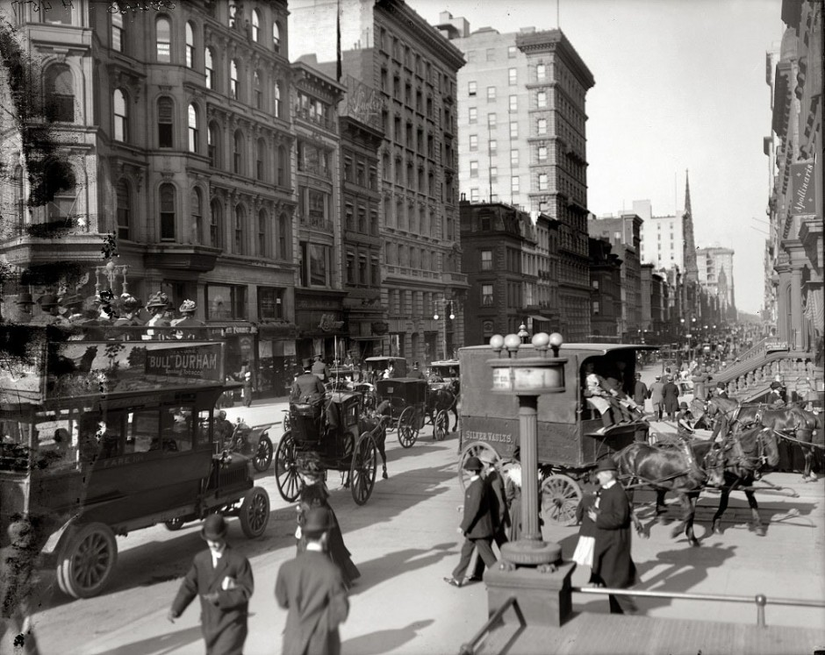
Corner of Fifth Avenue and 42nd Street, New York, 1910.

14.
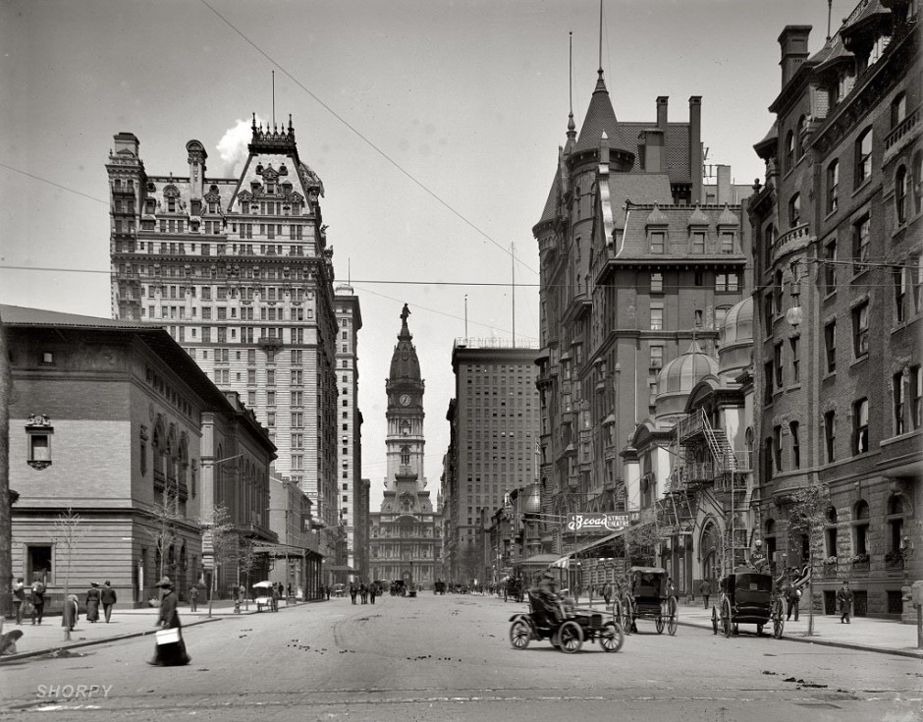
Broad Street north of Spruce Street, Philadelphia, 1905.

15.
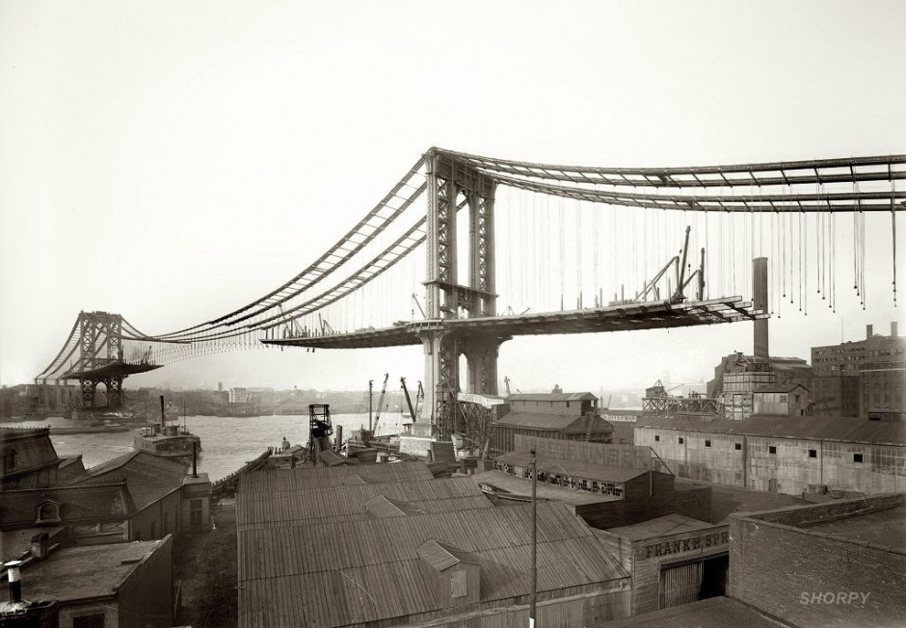
View of Manhattan Bridge from Brooklyn in 1909.

16.
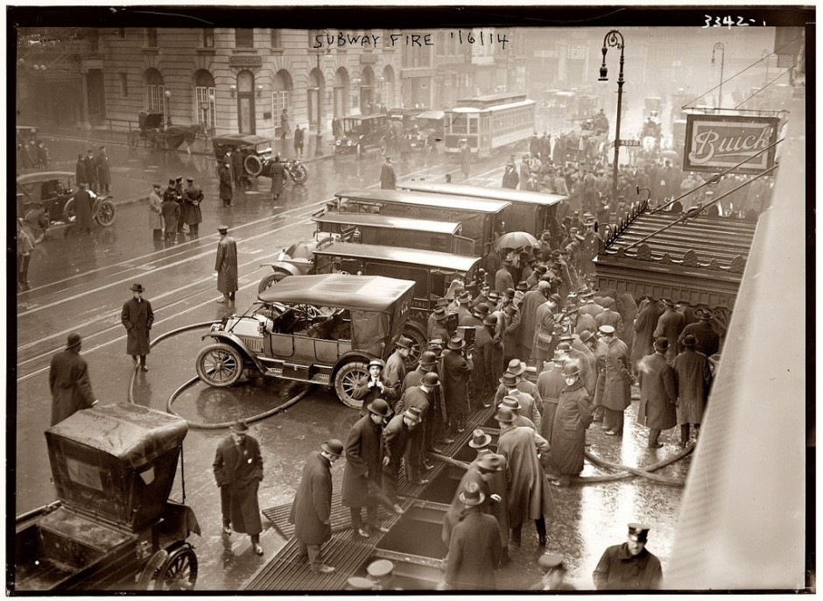
Fire at 55th Street, New York, 1914.

17.
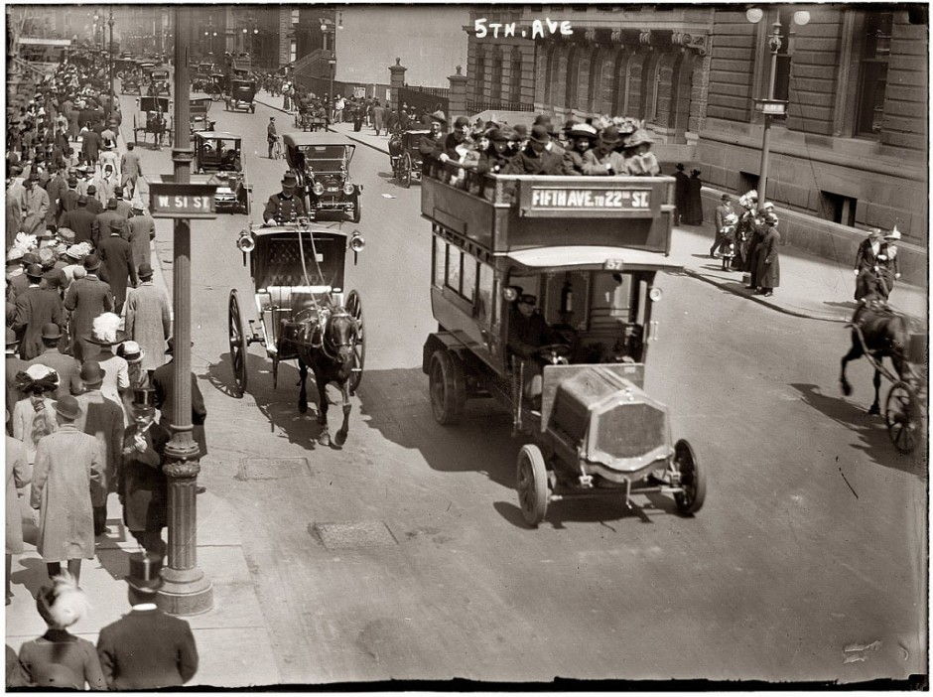
Fifth Avenue, New York, 1913.

18.
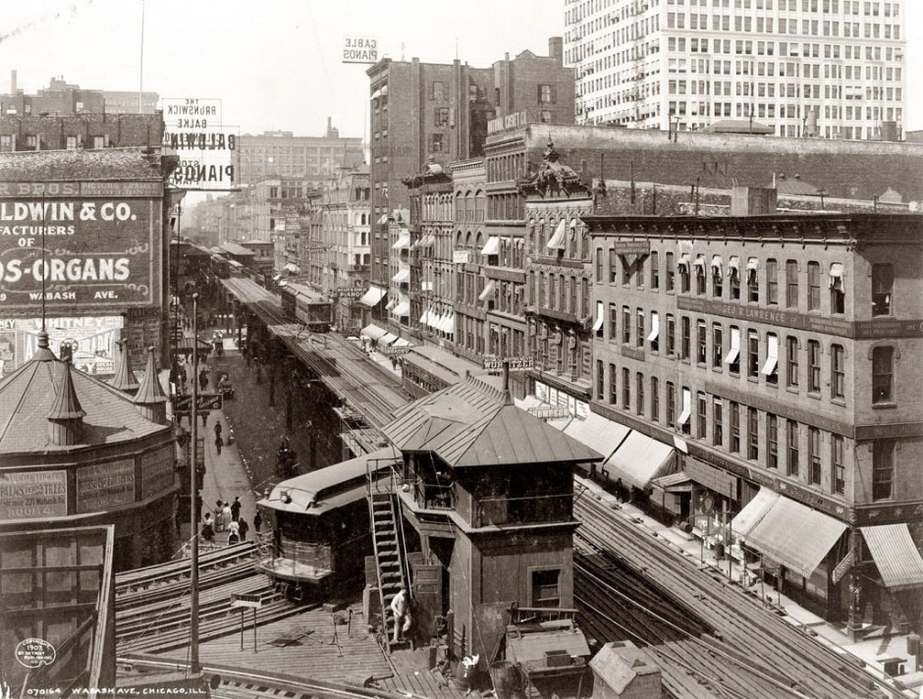
Wabash Avenue, Chicago, 1907.

19.
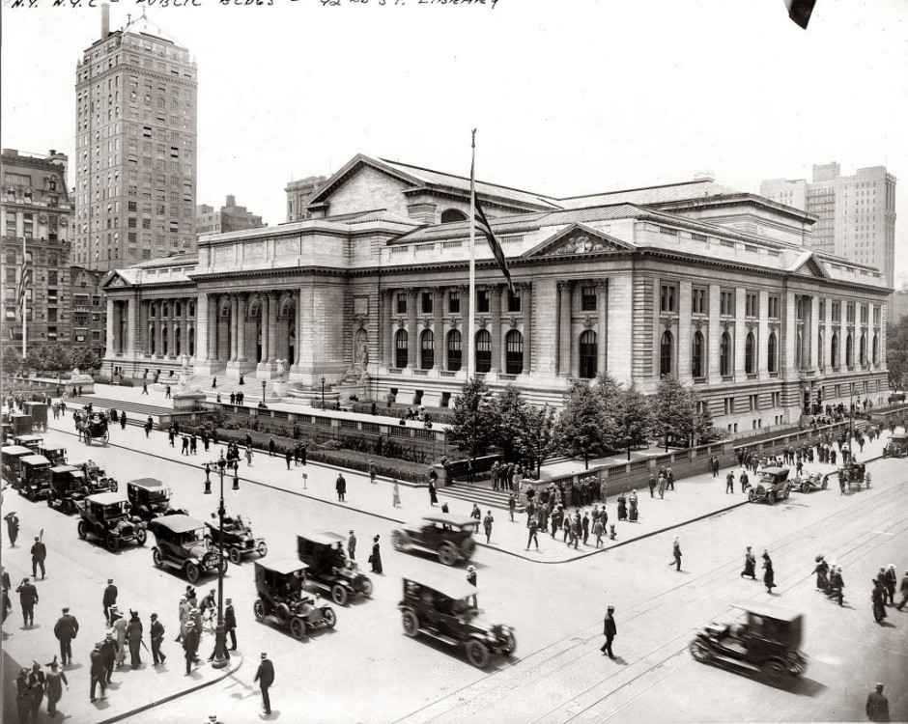
The New York Public Library, New York, 1915.
Didn't realize they had 4-laners in those days.

20.
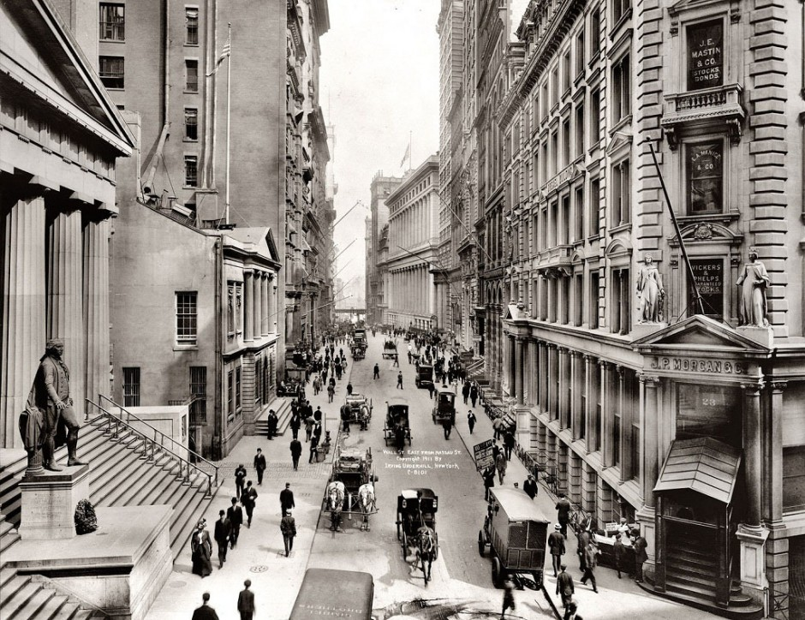
Wall Street, New York, 1911.
The 2 sidewalks together are as wide as the street in this pic.

21.
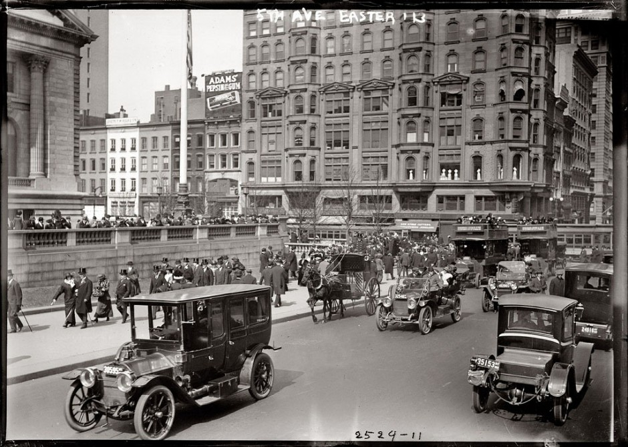
Fifth Avenue, New York, 1913.
Look at those top hats!

22.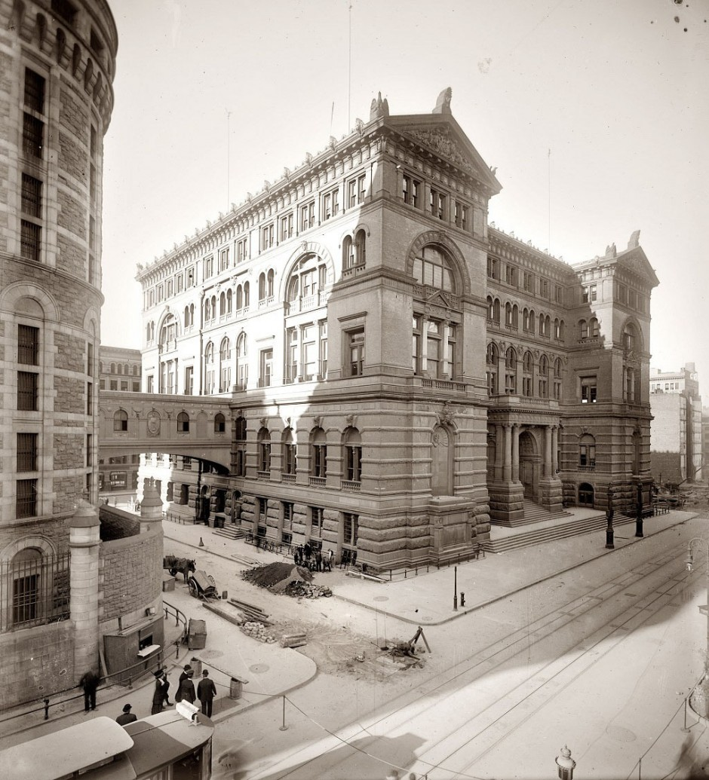
Manhattan, 1907.

23.
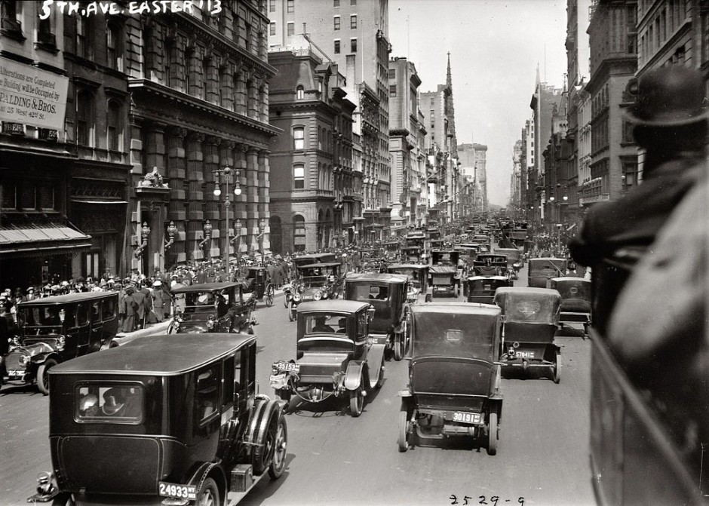
The northern part of Fifth Avenue, New York, 1913.
Must have been something big going on. ( Easter Parade? ) Look at the crowds and traffic jams.

24.
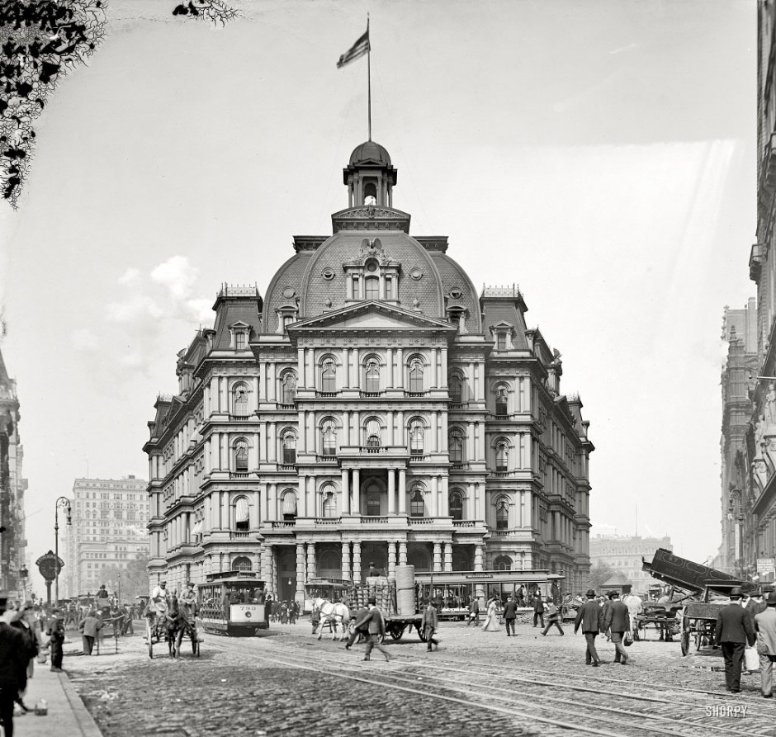
City Hall in New York.

25.
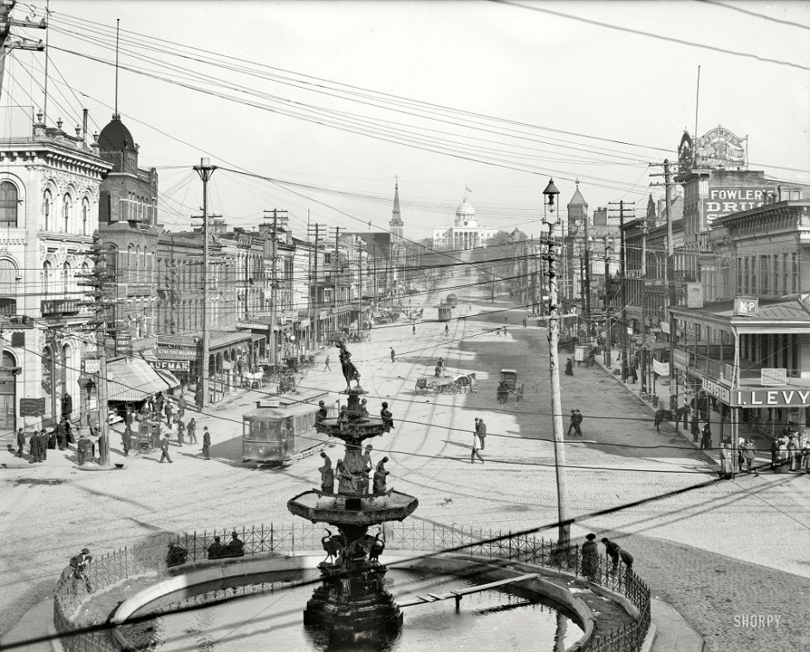
Dexter Avenue and the Capitol, Montgomery, Alabama, in 1906.
WoW! Really wide street. - 6-lane and it's practically empty.

26.
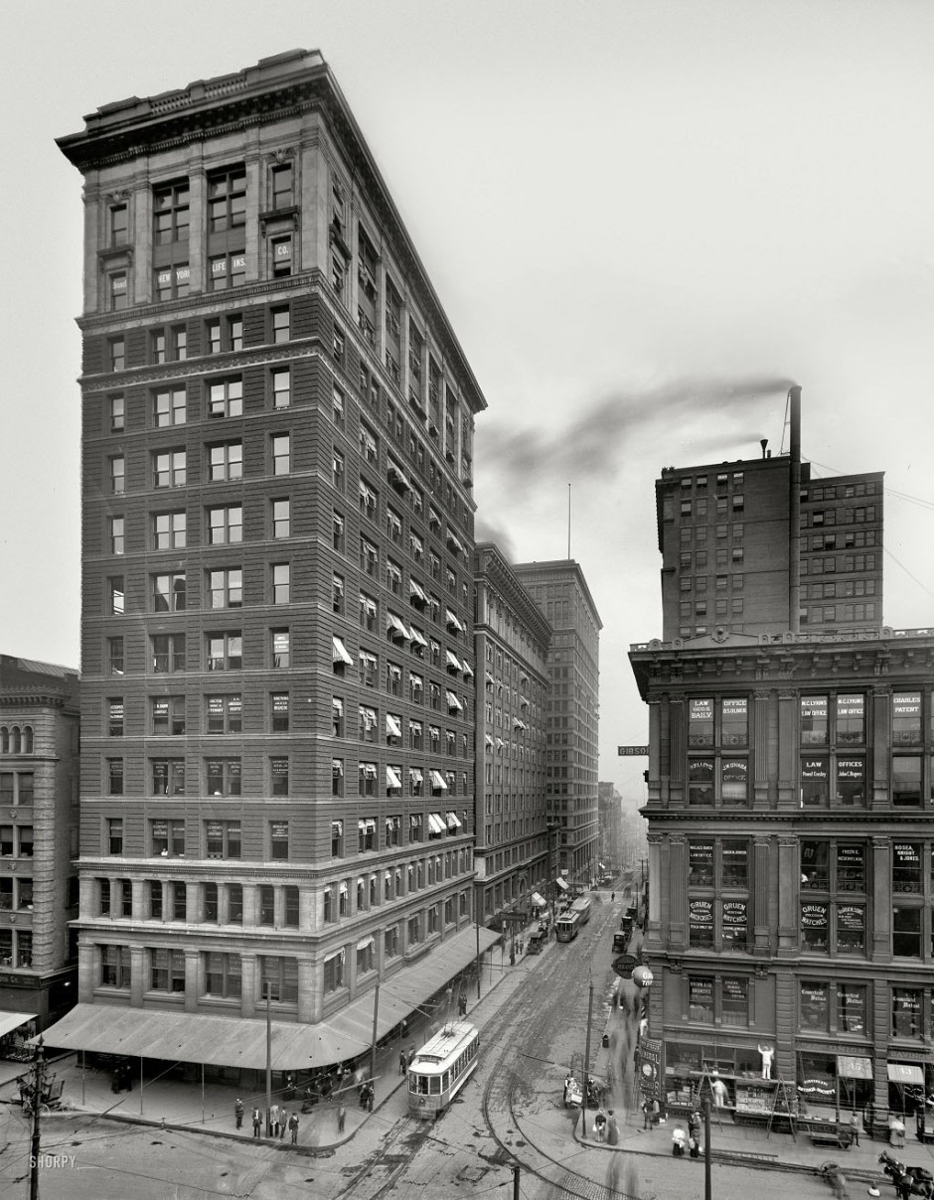
Valnut Street, Cincinnati, Ohio, 1910
(that's Walnut Street)
27.
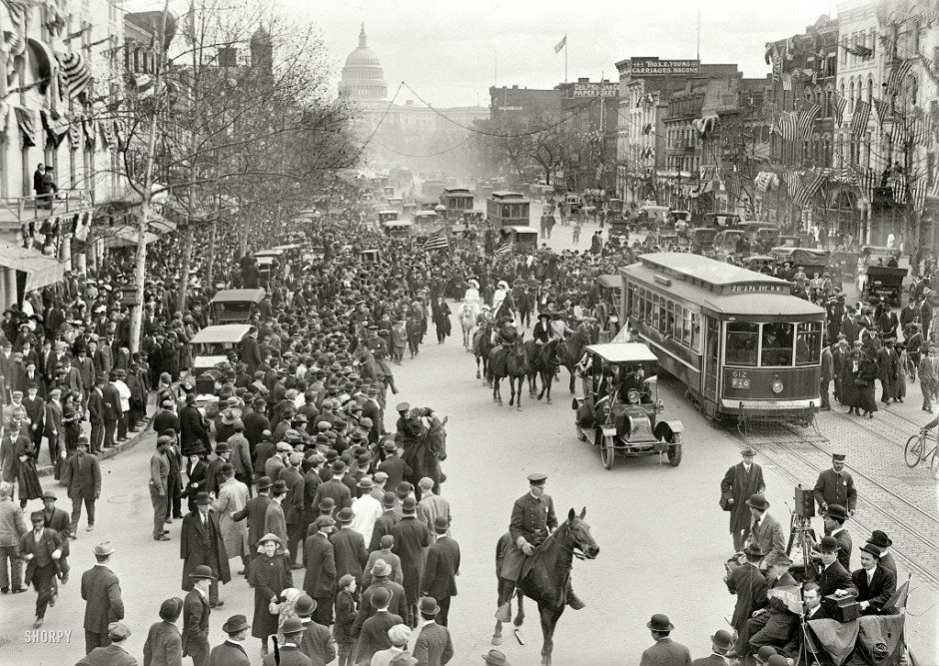
Washington, DC, 1913.

28. 

