"Good and evil are not myths, although many myths have been written about them: they are biological laws no more arbitrary or subjective than any of the laws of mathematics or chemistry. Morality is not some superstitious fairy tale: it is the mathematics of survival." - James Hart

The Beast as Saint: The Truth About Martin Luther King
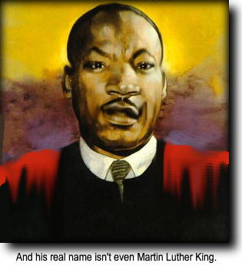
by Kevin Alfred Strom (the text of a speech given by Mr. Strom in 1994 on the nationwide radio program, American Dissident Voices)
WHEN THE COMMUNISTS TOOK OVER a country, one of the first things that they did was to confiscate all the privately-held weapons, to deny the people the physical ability to resist tyranny. But even more insidious than the theft of the people’s weapons was the theft of their history. Official Communist “historians” rewrote history to fit the current party line. In many countries, revered national heroes were excised from the history books, or their real deeds were distorted to fit Communist ideology, and Communist killers and criminals were converted into official “saints.” Holidays were declared in honor of the beasts who murdered countless nations. Did you know that much the same process has occurred right here in America?
Every January, the media go into a kind of almost spastic frenzy of adulation for the so-called “Reverend Doctor Martin Luther King, Jr.” King has even had a national holiday declared in his honor, an honor accorded to no other American, not Washington, not Jefferson, not Lincoln. (Washington and Lincoln no longer have holidays — they share the generic-sounding “President’s Day.”) A liberal judge has sealed the FBI files on King until the year 2027. What are they hiding? Let’s take a look at this modern-day plastic god.
Born in 1929, King was the son of a Black preacher known at the time only as “Daddy King.” “Daddy King” named his son Michael. In 1935, “Daddy King” had an inspiration to name himself after the Protestant reformer Martin Luther. He declared to his congregation that henceforth they were to refer to him as “Martin Luther King” and to his son as “Martin Luther King, Jr.” None of this name changing was ever legalized in court. “Daddy” King’s son’s real name is to this day Michael King.

King’s Brazen Cheating
We read in Michael Hoffman’s Holiday for a Cheater:
The first public sermon that King ever gave, in 1947 at the Ebenezer Baptist Church, was plagiarized from a homily by Protestant clergyman Harry Emerson Fosdick entitled “Life is What You Make It,” according to the testimony of King’s best friend of that time, Reverend Larry H. Williams. The first book that King wrote, Stride Toward Freedom, was plagiarized from numerous sources, all unattributed, according to documentation recently assembled by sympathetic King scholars Keith D. Miller, Ira G. Zepp, Jr., and David J. Garrow. And no less an authoritative source than the four senior editors of The Papers of Martin Luther King, Jr. (an official publication of the Martin Luther King Center for Nonviolent Social Change, Inc., whose staff includes King’s widow Coretta), stated of King’s writings at both Boston University and Crozer Theological Seminary: “Judged retroactively by the standards of academic scholarship, [his writings] are tragically flawed by numerous instances of plagiarism…. Appropriated passages are particularly evident in his writings in his major field of graduate study, systematic theology.” King’s essay, “The Place of Reason and Experience in Finding God,” written at Crozer, pirated passages from the work of theologian Edgar S. Brightman, author of The Finding of God. Another of King’s theses, “Contemporary Continental Theology,” written shortly after he entered Boston University, was largely stolen from a book by Walter Marshall Horton. King’s doctoral dissertation, “A Comparison of the Conceptions of God in the Thinking of Paul Tillich and Harry Nelson Wieman,” for which he was awarded a PhD in theology, contains more than fifty complete sentences plagiarized from the PhD dissertation of Dr. Jack Boozer, “The Place of Reason in Paul Tillich’s Concept of God.”
According to The Martin Luther King Papers, in King’s dissertation “only 49 per cent. of sentences in the section on Tillich contain five or more words that were King’s own….”!
In The Journal of American History, June 1991, page 87, David J. Garrow, a leftist academic who is sympathetic to King, says that King’s wife, Coretta Scott King, who also served as his secretary, was an accomplice in his repeated cheating. Reading Garrow’s article, one is led to the inescapable conclusion that King cheated because he had chosen for himself a political role in which a PhD would be useful, and, lacking the intellectual ability to obtain the title fairly, went after it by any means necessary. Why, then, one might ask, did the professors at Crozer Theological Seminary and Boston University grant him passing grades and a PhD? Garrow states on page 89: “King’s academic compositions, especially at Boston University, were almost without exception little more than summary descriptions… and comparisons of other’s writings. Nonetheless, the papers almost always received desirable letter grades, strongly suggesting that King’s professors did not expect more….”
The editors of The Martin Luther King Jr. Papers state that “…the failure of King’s teachers to notice his pattern of textual appropriation is somewhat remarkable….”
But researcher Michael Hoffman tells us “…actually the malfeasance of the professors is not at all remarkable. King was politically correct, he was Black, and he had ambitions. The leftist [professors were] happy to award a doctorate to such a candidate no matter how much fraud was involved. Nor is it any wonder that it has taken forty years for the truth about King’s record of nearly constant intellectual piracy to be made public.”
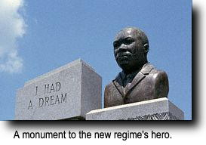
Supposed scholars, who in reality shared King’s vision of a racially mixed and Marxist America, purposely covered up his cheating for decades. The cover-up still continues. From the New York Times of October 11, 1991, page 15, we learn that on October 10th of that year, a committee of researchers at Boston University admitted that, “There is no question but that Dr. King plagiarized in the dissertation.” However, despite its finding, the committee said that “No thought should be given to the revocation of Dr. King’s doctoral degree,” an action the panel said “would serve no purpose.”
No purpose, indeed! Justice demands that, in light of his willful fraud as a student, the titles “reverend” and the “doctor” should be removed from King’s name.

Communist Beliefs and Connections
Well friends, he is not a legitimate reverend, he is not a bona fide PhD, and his name isn’t really “Martin Luther King, Jr.” What’s left? Just a sexual degenerate, an America-hating Communist, and a criminal betrayer of even the interests of his own people.
On Labor Day, 1957, a special meeting was attended by Martin Luther King and four others at a strange institution called the Highlander Folk School in Monteagle, Tennessee. The Highlander Folk School was a Communist front, having been founded by Myles Horton (Communist Party organizer for Tennessee) and Don West (Communist Party organizer for North Carolina). The leaders of this meeting with King were the aforementioned Horton and West, along with Abner Berry and James Dumbrowski, all open and acknowledged members of the Communist Party, USA. The agenda of the meeting was a plan to tour the Southern states to initiate demonstrations and riots.
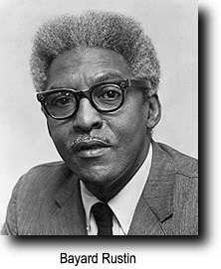
From 1955 to 1960, Martin Luther King’s associate, advisor, and personal secretary was one Bayard Rustin. In 1936 Rustin joined the Young Communist League at New York City College. Convicted of draft-dodging, he went to prison for two years in 1944. On January 23, 1953 the Los Angeles Times reported his conviction and sentencing to jail for 60 days for lewd vagrancy and homosexual perversion. Rustin attended the 16th Convention of the Communist Party, USA in February, 1957. One month later, he and King founded the Southern Christian Leadership Conference, or SCLC for short. The president of the SCLC was Dr. Martin Luther King, Jr. The vice-president of the SCLC was the Reverend Fred Shuttlesworth, who was also the president of an identified Communist front known as the Southern Conference Educational Fund, an organization whose field director, a Mr. Carl Braden, was simultaneously a national sponsor of the Fair Play for Cuba Committee, of which you may have heard. The program director of the SCLC was the Reverend Andrew Young, in more recent years Jimmy Carter’s ambassador to the UN and mayor of Atlanta. Young, by the way, was trained at the Highlander Folk School, previously mentioned.
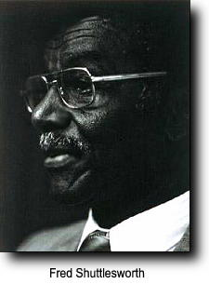
Soon after returning from a trip to Moscow in 1958, Rustin organized the first of King’s famous marches on Washington. The official organ of the Communist Party, The Worker, openly declared the march to be a Communist project. Although he left King’s employ as secretary in 1961, Rustin was called upon by King to be second in command of the much larger march on Washington which took place on August 28, 1964.
Bayard Rustin’s replacement in 1961 as secretary and advisor to King was Jack O’Dell, also known as Hunter Pitts O’Dell. According to official records, in 1962 Jack O’Dell was a member of the National Committee of the Communist Party, USA. He had been listed as a Communist Party member as early as 1956. O’Dell was also given the job of acting executive director for SCLC activities for the entire Southeast, according to the St. Louis Globe-Democrat of October 26, 1962. At that time, there were still some patriots in the press corps, and word of O’Dell’s party membership became known.
What did King do? Shortly after the negative news reports, King fired O’Dell with much fanfare. And he then, without the fanfare, immediately hired him again as director of the New York office of the SCLC, as confirmed by the Richmond News-Leader of September 27, 1963.
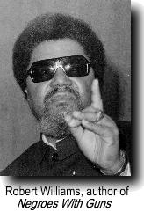
In 1963 a Black man from Monroe, North Carolina named Robert Williams made a trip to Peking, China. Exactly 20 days before King’s 1964 march on Washington, Williams successfully urged Mao Tse-Tung to speak out on behalf of King’s movement. Mr. Williams was also around this time maintaining his primary residence in Cuba, from which he made regular broadcasts to the southern United States, three times a week, from high-power AM transmitters in Havana under the title “Radio Free Dixie.” In these broadcasts, he urged violent attacks by Blacks against White Americans.
During this period, Williams wrote a book entitled Negroes With Guns. The writer of the foreword for this book? None other than “Martin Luther King, Jr.” It is also interesting to note that the editors and publishers of this book were to a man all supporters of the infamous Fair Play for Cuba Committee.
According to King’s biographer and sympathizer David J. Garrow, “King privately described himself as a Marxist.” In his 1981 book, The FBI and Martin Luther King, Jr., Garrow quotes King as saying in SCLC staff meetings, “…we have moved into a new era, which must be an era of revolution…. The whole structure of American life must be changed…. We are engaged in the class struggle.”
Jewish Communist Stanley Levison can best be described as King’s behind-the-scenes “handler.” Levison, who had for years been in charge of the secret funnelling of Soviet funds to the Communist Party, USA, was King’s mentor and was actually the brains behind many of King’s more successful ploys. It was Levison who edited King’s book, Stride Toward Freedom. It was Levison who arranged for a publisher. Levison even prepared King’s income tax returns! It was Levison who really controlled the fund-raising and agitation activities of the SCLC. Levison wrote many of King’s speeches. King described Levison as one of his “closest friends.”

FBI: King Bought Sex With SCLC Money
The Federal Bureau of Investigation had for many years been aware of Stanley Levison’s Communist activities. It was Levison’s close association with King that brought about the initial FBI interest in King.
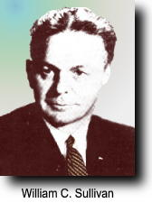
Lest you be tempted to believe the controlled media’s lie about “racists” in the FBI being out to “get” King, you should be aware that the man most responsible for the FBI’s probe of King was Assistant Director William C. Sullivan. Sullivan describes himself as a liberal, and says that initially “I was one hundred per cent. for King…because I saw him as an effective and badly needed leader for the Black people in their desire for civil rights.” The probe of King not only confirmed their suspicions about King’s Communist beliefs and associations, but it also revealed King to be a despicable hypocrite, an immoral degenerate, and a worthless charlatan.
According to Assistant Director Sullivan, who had direct access to the surveillance files on King which are denied the American people, King had embezzled or misapplied substantial amounts of money contributed to the “civil rights” movement. King used SCLC funds to pay for liquor, and numerous prostitutes both Black and White, who were brought to his hotel rooms, often two at a time, for drunken sex parties which sometimes lasted for several days. These types of activities were the norm for King’s speaking and organizing tours.
In fact, an outfit called the “National Civil Rights Museum” in Memphis, Tennessee, which is putting on display the two bedrooms from the Lorraine Motel where King stayed the night before he was shot, has declined to depict in any way the occupants of those rooms. That—according to exhibit designer Gerard Eisterhold—would be “close to blasphemy.” The reason? “Dr. Martin Luther King, Jr.” spent his last night on Earth having sexual intercourse with two women at the motel and physically beating and abusing a third.
Sullivan also stated that King had alienated the affections of numerous married women. According to Sullivan, who in 30 years with the Bureau had seen everything there was to be seen of the seamy side of life, King was one of only seven people he had ever encountered who was such a total degenerate.
Noting the violence that almost invariably attended King’s supposedly “non-violent” marches, Sullivan’s probe revealed a very different King from the carefully crafted public image. King welcomed members of many different Black groups as members of his SCLC, many of them advocates and practitioners of violence. King’s only admonition on the subject was that they should embrace “tactical nonviolence.”
Sullivan also relates an incident in which King met in a financial conference with Communist Party representatives, not knowing that one of the participants was an infiltrator actually working for the FBI.
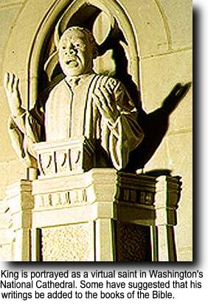
J. Edgar Hoover personally saw to it that documented information on King’s Communist connections was provided to the President and to Congress. And conclusive information from FBI files was also provided to major newspapers and news wire services. But were the American people informed of King’s real nature? No, for even in the 1960s, the fix was in—the controlled media and the bought politicians were bound and determined to push their racial mixing program on America. King was their man and nothing was going to get in their way. With a few minor exceptions, these facts have been kept from the American people. The pro-King propaganda machine grinds on, and it is even reported that a serious proposal has been made to add some of King’s writings as a new book in the Bible.
Ladies and gentlemen, the purpose of this radio program is far greater than to prove to you the immorality and subversion of this man called King.
I want you to start to think for yourselves.
I want you to consider this: What are the forces and motivation behind the controlled media’s active promotion of King?
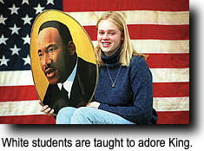
What does it tell you about our politicians when you see them, almost without exception, falling all over themselves to honor King as a national hero?
What does it tell you about our society when any public criticism of this moral leper and Communist functionary is considered grounds for dismissal?
What does it tell you about the controlled media when you see how they have successfully suppressed the truth and held out a picture of King that can only be described as a colossal lie?
You need to think, my fellow Americans. You desperately need to wake up.
__________________
Bibliography
1. Hoffman, Michael A., Holiday for a Cheater, (Wiswell Ruffin House, Dresden, New York, 1992)
2. Steffgen, Kent H., Bondage of the Free, (Vanguard Books, Berkeley, California, 1966)
3. Garrow, David J., The FBI and Martin Luther King, Jr., (W. W. Norton & Co, New York City, 1981)
Further information on King’s Communist connections and the FBI surveillance of Stanley Levison can be found in the Congressional Record.

Source: http://www.kevinalfredstrom.com/2008/10/beast-as-saint/

